International Union of Elevator Constructors

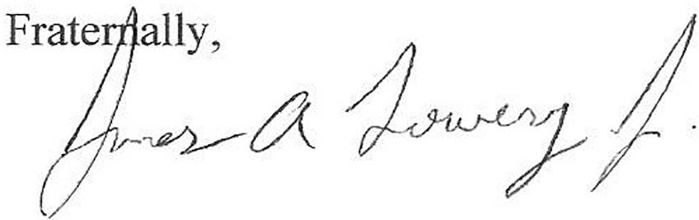

Frank J. Christensen

*General President*

James K. Bender, II

*Assistanr General President*

Larry J. McGann

*General Secretary-Treasurer*

Vice Presidents Leonard R. Legotte

Tony T. Gazzaniga Mike Funk

Joseph M. Williams

F. Allen Thompson Patrick W. Strafer David A. Griefenhagen Gregory L. Levenson Bradley N. Brave Timothy J. Gray

*HEADQUARTERS*

7154 Columbia Gateway Drive Columbia, MD 21046 [http://www.iuec.org](http://www.iuec.org/)

*TELEPHONE*

(410) 953-6150

*FAX*

(410) 953-6169

*Affiliated with the AFL-CIO*

July 12, 2021

Re: Out of Country/Overseas Project Opportunities IUEC Regional Directors and Organizers,

The purpose of this correspondence is to determine who within our membership may be seriously interested in traveling outside the United States to perform Elevator Constructor work on conveyances, meaning maintenance, testing, inspections, repairs, modernization and/or construction.

Interested members can contact me by email at their earliest convenience. Understand that expressing interest does not commit anyone to enroll in a specific project or engage in any agreement. These opportunities/positions may require security clearance conducted by the U.S. Government.

In closing, I encourage you to distribute this information to the Locals in your area. Questions can be emailed to me at [jlowery@iuec.org.](mailto:jlowery@iuec.org) Thanks in advance for your assistance.

James Lowery

IUEC National Organizer Office (301) 373-2174